1. Introduction

1.1. What is SpecterX
Collaboration is a significant part of any business process, from working with partners and suppliers to managing customers and board communications. Cloud transformation enables and simplifies this. However, while organizations are moving forward to increase productivity, data owners and security teams are concerned with the safety of their digital supply chain, exposing the company’s data and sensitive IP to significant security, privacy, and regulatory risks.
SpecterX allows you to decide how to manage your organizational data. SpecterX knows data can transform your business, drive your innovation, and improve your competitive edge. That’s why we aim to maximize your control over your data in a seamless, secure, and productive manner, helping you meet your business goals.

Collaborate with external entities without giving away data ownership
SpecterX brings complete visibility, total control, and extensive protection over data downstream across the digital supply chain, using one single platform. SpecterX allows organizations to use their data everywhere while managing and protecting it according to their set of rules and policies.

1.2. Purpose of this document
This document was written with 3 goals in mind:
- Collect all the information we need to set up the SpecterX solution in your organization.
- Provide you with all the information you need to integrate the SpecterX solution into your organization.
- Describe the settings and infrastructure needed for SpecterX to work in your organization.

If your network architecture also uses a DMZ segment, you should receive an additional document with the deployment requirements for the DMZ segment.

Please help us by filling-in/verifying all fields marked with yellow markers.

2. Architecture

2.1. Overview

2.1.1. An Hybrid-Onprem Architecture
SpecterX offers a hybrid solution for enterprises with an isolated LAN network. This solution integrates with all of the organization's on-premise systems, providing the benefits of working in an isolated environment while still having access to the benefits of a cloud solution.

With the hybrid solution, organizations can enjoy the regular and short-interval updates that are typically associated with cloud-based solutions, giving all users the latest version of the SpecterX platform. This allows internal and external users to access the most up-to-date information and ensures that the organization's data is secure and up-to-date.

In this way, SpecterX's hybrid solution offers a balance between security, control, and accessibility, making it an ideal solution for organizations that are concerned about the safety of their digital supply chain, but also want to be able to collaborate and share data with external entities.

2.1.2. Polling - No incoming traffic
SpecterX uses Polling as part of its onprem architecture solution. In this solution, the internal system components will initiate one-way communication to the external system component in which the external services will be asked about requests to send information. Thus, we can prevent two-way communication between the components in the external networks and the internal networks.

By using polling, SpecterX can ensure that sensitive information and data remains within the secure perimeter of the organization's internal network while still allowing external entities to access it. The one-way communication helps maintain control over the flow of data, ensuring that it remains secure and that the organization can enforce its security policies and regulations. Additionally, the use of polling reduces the risk of unauthorized access to sensitive data and protects against cyber threats and data breaches. This way, SpecterX offers a secure and reliable solution for organizations looking to manage and protect their sensitive data while still enabling collaboration with external entities.

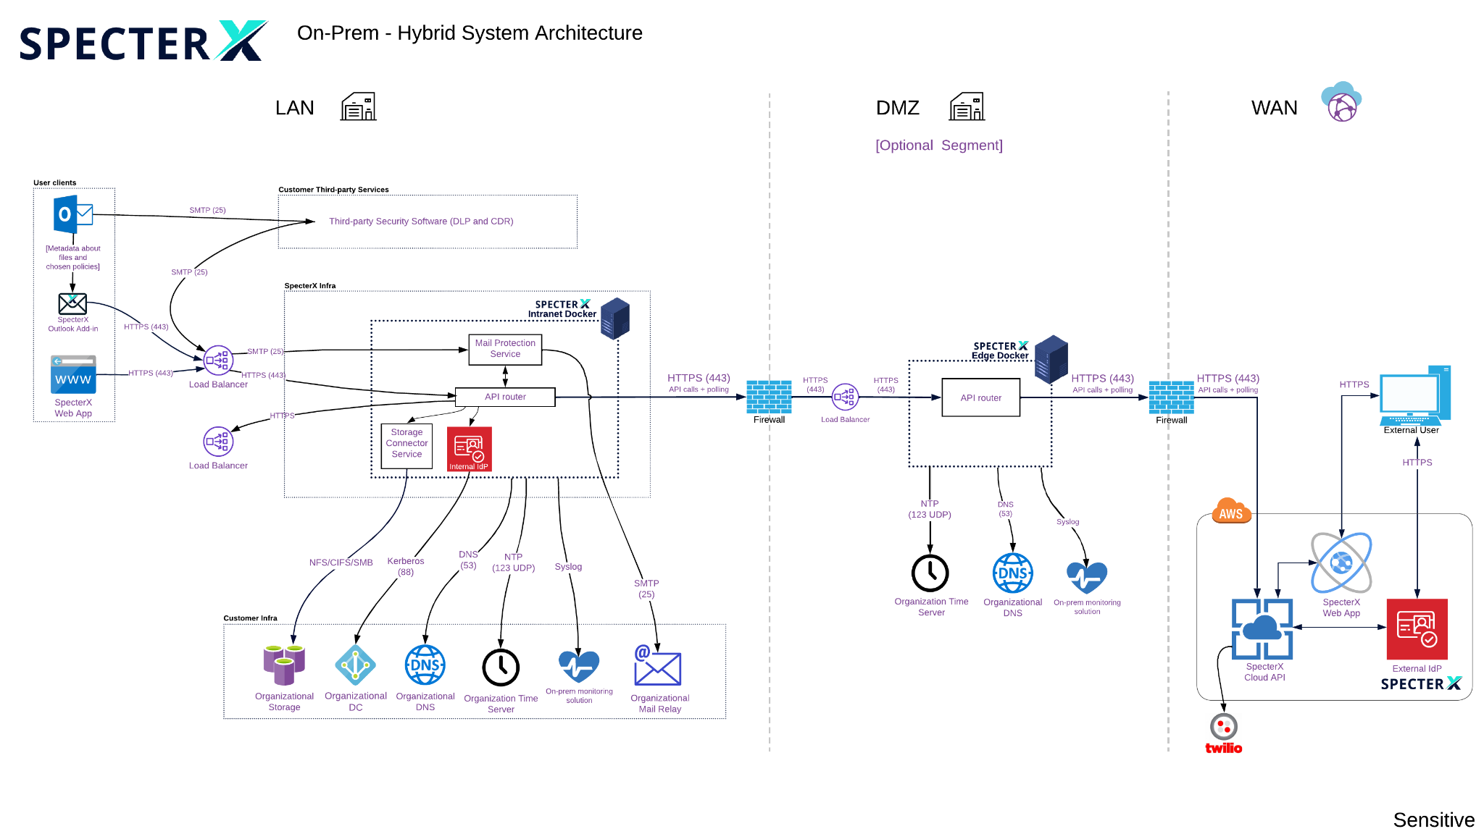
2.2. Diagram

2.3. Components Overview

2.3.1. Onprem Components

2.3.1.1. SpecterX Outlook Addin
The SpecterX Outlook Addin let’s users apply SpecterX protection to their outgoing emails.
This Addin adds an “Enable Protection” to the Outlook email composer. Once clicked, the email will be marked for protection and the user has the ability to define which policies to apply to the email and its attachments, as well as set permission levels for the recipients.

2.3.1.2. Intranet Docker
All of our Intranet services run on a Docker server installed on a virtual machine provided by the customer. For stability and redundancy, we recommend bringing up at least two instances of this server, and setting them up behind a Load Balancer.

2.3.1.3. Mail Protection Service
The Mail Protection Service (also known as MPS) is an SMTP server, that once added to the mailing flow in the organization, receives emails marked for protection and protects them based on the applied policies.

It does by going through the following steps:
- Validate that the email was indeed marked for protection. If not, it sends the email to the next hop in the mailing flow.
- Strip the email from its files and store them back in the organizational storage.
- Attach secure links instead of the files.
- Enforce policies and permissions on these links based on the user and organization choices.
- Send the email to the next hop in the mailing flow.

2.3.1.4. Storage Connector Service
The Storage Connector Service connects to the organizational storage that was chosen to store files protected by SpecterX. It is a bridge for other SpecterX components which wish to save or read files from the storage.

Any request to open or download a file will pass through this service to fetch the file, limiting access to the storage to a single point.
To keep your organization safe, requests coming from users outside the organizations will be done by polling - the storage connector will check for any file request once every few seconds, and initiate a response with the requested file.

2.3.1.5. API Router (LAN)
Any communication to SpecterX services in the LAN network will go through our API router.
This router allows communication between users and all the services mentioned above.

2.3.1.6. API Router (DMZ)
In case the organization has a DMZ network segment, there will be an additional API router in that segment, passing all requests coming in and out of the LAN API router.

2.3.1.7. Internal IdP
SpecterX deploys a thin Identity Provider as part of its solution, to integrate to your own identity provider, such as Active Directory.

2.3.2. Cloud Components

2.3.2.1. Cloud API
This is the entry point for all communication from the cloud to the SpecterX on-premise infrastructure.
It communicates with the API Router in the DMZ network segment (if exists) or directly with the API Router in the LAN network.

2.3.2.2. SpecterX Web App
The SpecterX Web App is the central point for all SpecterX management and administration.
It communicates with the Cloud API to perform all the administrative tasks, such as setting policies, adding users and permissions, and retrieving data insights and analytics.

The Web App is available for both internal and external users.

2.3.2.3. External IdP
External users are authenticated directly through SpecterX, and creates identities for them on-the-fly the moment they try to access the data shared with them.

That way, your organization doesn’t need to do anything to onboard external users, and can still manage them and see their actions through SpecterX’s audit logs.

2.3.2.4. Twilio
SpecterX uses trusted third-party service providers to generate email and SMS notifications.

2.4. Data Flow

2.4.1. Outbound Flow
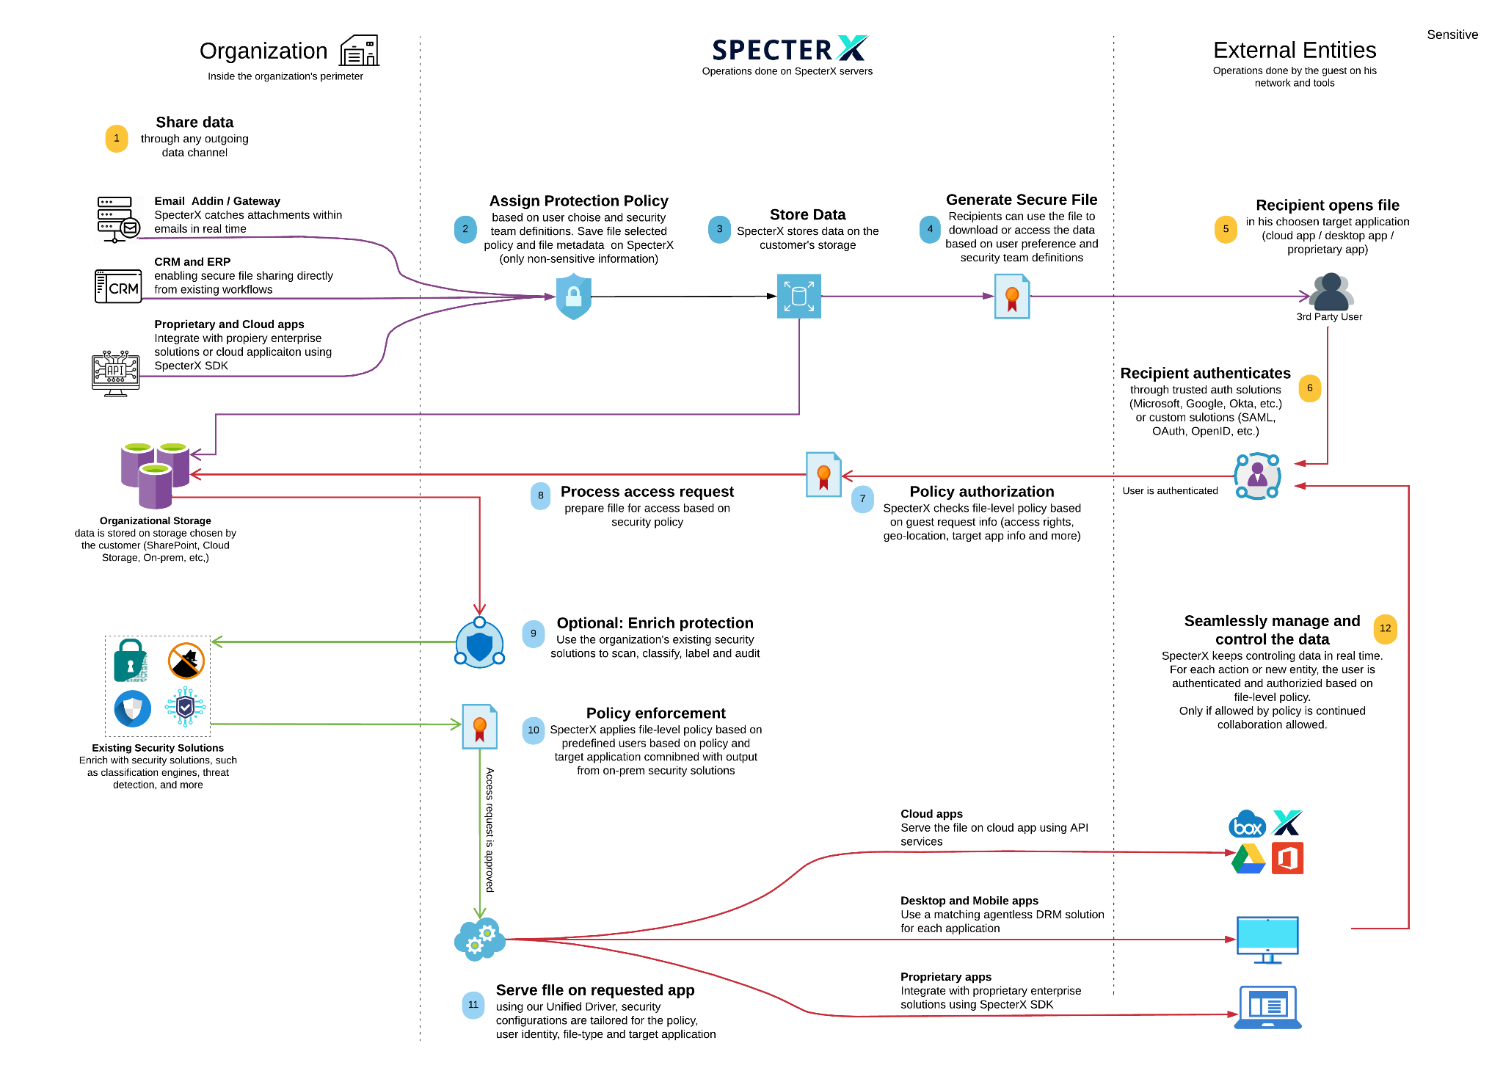
Below is an overview of an outbound flow through the platform, in relation to the architecture. Bolded text is an object displayed in the HLD diagram above

2.4.1.1. Data Owner (Organization user) - Shares data with external entity
- Data Owner shares sensitive data via one of the organization’s collaboration channels (Email / SpecterX Web App / CRM / etc.).
- Data share is intercepted by Data Leak Prevention (DLP) infrastructure.
- DLP infrastructure redirects the sharing request to the SpecterX On-Prem component.
- The SpecterX On-Prem component goes throught the following steps:
  - Assign a protection policy based on predefined rules.
  - Store the data on the organization’s storage solution (On-Prem)
  - Generates a secure file link
  - Continue the original sharing flow (Send email / Share file / etc.)

2.4.1.2. External Entity - Access secured data via SpecterX
- External entity access the attached secure data and is redirected to the SpecterX recipient page on the SpecterX Web app (part of the SpecterX Cloud component)
- SpecterX Cloud Component
  - Authenticates the external entity according to the organization’s policy (OTP / 2FA / etc.)
  - Determine and set the appropriate policy based on the external entity request info (access rights, geo-location, target app, etc.)
  - Process access request from the SpecterX On-Prem component (Polling)
- SpecterX On-Prem component Streams the data to the SpecterX Cloud component.
- External Entity accesses the data using his own preferred tools (SpecterX Viewer / Google / Office365 / Download / etc.)
  - SpecterX enforces real-time file-level protection policy.

2.4.2. Inbound Flow
Below is an overview of an inbound flow through the platform, in relation to the architecture. Bolded text is an object displayed in the HLD diagram above

2.4.2.1. External Entity - Shares data with Organization user
- External entities share data with organization users.
- SpecterX Cloud API receives the file and creates a data upload polling request to the SpecterX On-Prem component.
- SpecterX On-Prem component pulls the data from the SpecterX Cloud API:
  - Sends the data to Content Disarm and Reconstruction (CDR) infrastructure.
  - Upon approval of the data by the CDR Infrastructure, a protection policy will be assigned to the data based on predefined rules.
  - The data will be stored in the organization's storage solution (On-Prem).
  - A secure file link will be generated for the data.
- SpecterX Cloud API will notify the Organization user via email.

3. Prerequisites

3.1. VM Provisioning and Specs
SpecterX’s system is composed of 2 instance types:
- Intranet VM - In charge of running and maintaining the core SpecterX services, such as authentication, connection to on-prem storage, connection to mail servers, etc...
- (optional) Edge VM - Performs the duty of the application request router to the Internet as well as a gateway that facilitates shipping of resource consumption metrics and service health indicators to SpecterX.

NOTE RAM and CPU resource consumption may vary according to usage in your organization. SpecterX personnel will proactively notify the technical contact in the case that additional resources are needed to comply with SLA requirements.

3.1.1. Intranet VM (2 instances) Resources
CPU cores 4 cores (>=2.2Ghz)
RAM 16 GB
Disk space 80GB
Network interface 1Gbps

SpecterX will provide a pre-baked OVF image to deploy on this VM.

3.2. User Provisioning
Service Account Username | specterx-dev
Service Account Password | JUtuEw6WN5

3.3. Network settings (LAN)
Please allocate and fill in the following network details:

Address purpose | IP (Mask)
LAN Load Balancer VIP for SpecterX | 172.27.106.206
SpecterX Intranet VM instance #1 | 172.27.106.205
SpecterX Intranet VM instance #1 Hostname | TAP9010T
SpecterX Intranet VM instance #2

Please fill in these network details for the following LAN resources:
Org LAN Netmask | 255.255.255.0
Org LAN Gateway | 172.27.106.1
Org LAN DNS servers (if there is more than one DNS server, please list all of them) | 172.27.215.164  172.27.216.99
Org LAN NTP server | NTP-LAN.migdal-group.co.il / 172.27.67.149
Org LAN Outgoing mail relay | smtpsrvr.migdal-dev.co.il:25
NAS Storage | 172.27.221.139
DC | migdal-dev.co.il

Domain Name | migdal-dev.co.il

What is 10.1.0.237
What is 10.1.0.251

PRODUTION DETAILS
other_internet_host_ip_address: 172.27.67.190
other_secondary_host_ip_address: 172.27.117.160
kerberos_kdc_server: 172.72.101.75

3.1.3. Required DNS/LB configuration
Please create the following DNS records and load balancer target groups:
DNS FQDN | LB group members | LB Port/Protocol
specterx.company.domain -> LAN LB VIP | Intranet VM1  Intranet VM2 | 443/TCP
spx-api.company.domain -> LAN LB VIP | Intranet VM1  Intranet VM2 | 443/TCP
spx-auth.company.domain -> LAN LB VIP | Intranet VM1  Intranet VM2 | 443/TCP
spx-mps.company.domain -> LAN LB VIP | Intranet VM1  Intranet VM2 | 25/SMTP
spx-transfer.company.domain -> LAN LB VIP | Intranet VM1  Intranet VM2 | 443/TCP
DNS records for resources in the DMZ network segment
spx-edgeapi.company.domain -> DMZ LB VIP | Edge VM1  Edge VM2 | 443/TCP

3.1.4. Required Firewall rules
Please open the following rules in your organization’s Firewalls:

# | Reason | Source | Destination | Port
 | Allow Outlook Addin on user workstations to access the SpecterX intranet services | User workstations / Citrix | spx-auth.company.domain  spx-api.company.domain  specterx.company.domain | TCP 443
 | Allow communications between our intranet services | Intranet VMs IPs (as allocated in section 2.1.2 of this document) | spx-auth.company.domain  spx-api.company.domain  specterx.company.domain | TCP 443
 | Allow communications between our intranet services and the DNS servers | Intranet VMs IPs (as allocated in section 2.1.2 of this document) | <LAN DNS resolvers> | TCP/UDP 53
 | In case the customer wants to install Splunk agent, this will rule allow communications between our intranet services and Splunk | Intranet VMs IPs (as allocated in section 2.1.2 of this document) | <Splunk server address> | UDP 514
 | Allow communications between our intranet services and the organization’s DLP service, for example Forcepoint | <DLP address> | spx-mps.company.domain | TCP 25
 | Allow communications between our intranet services and the dedicated NAS storage | Intranet VMs IPs (as allocated in section 2.1.2 of this document) | 172.27.221.139  migdal-group.co.il\dfs$\SpecterX-T  nasct.migdal-group.co.il:/apps/SpecterX-T | TCP 445/  2049+111
 | Sending email notifications to recipients and file owners | Intranet VMs IPs (as allocated in section 2.1.2 of this document) | <LAN SMTP mail relay> | TCnP 25
 | Synchronizing server clocks to match log times with the customer’s systems | Intranet VMs IPs (as allocated in section 2.1.2 of this document) | <LAN NTP address> | UDP 123
 | Authenticating users inside the customer’s domain | Intranet VMs IPs (as allocated in section 2.1.2 of this document) | <AD/Domain address> | TCP 88

3.1.5. Additional Firewall Rules - Required for Maintenance
This rule is related to ​​section 3.4. Testing and Maintenance Environment for SpecterX and this would greatly speed up delivery of new features as well as substantially decrease risks when rolling out new versions to end-users. More information in section 3.4.

#1 | Allow communication from testing workstation to access the SpecterX intranet services directly | Intranet VMs IPs (as allocated in section 2.1.2 of this document) | SpecterX Intranet VM instance #1  SpecterX Intranet VM instance #2 | TCP 443 + SSH 22

3.2. SSL Certificates
SpecterX solution relies on SSL/TLS to provide end-to-end encryption of data in motion and ensure server identity. It is up to the customer to provide the appropriate SSL certificate(s).

Important: SpecterX requires that the certificate be provisioned by a commonly trusted authority (or signed by a corporate CA). Any level of authority is acceptable as long as the CA chain is provided.

Certificate scope | Common Name | Subject Alt Names
Intranet SSL certificate | specterx.company.domain | spx-api.company.domain  spx-edgeapi.company.domain  spx-auth.company.domain  spx-mps.company.domain

3.3. Authentication & SSO
Our solution supports the following authentication & authorization methods:
- SpecterX cloud iDP with either in-house or federated user pool management
- SpecterX on-prem iDP with federated authentication against Active Directory (Kerberos)
- SpecterX embedded iDP with a self-contained user pool

As authentication and identity management solutions tend to be highly specific - please contact us to discuss the preferred solution in detail.

3.3.1. Registering SPN for SpecterX Authentication in Active Directory
The company needs to add below on the company's AD server.

setspn -S HTTP/spx-auth.<customer_domain> <service_account>

The command “setspn -S HTTP/spx-auth.<customer_domain> <service_account>” is used to register a Service Principal Name (SPN) for a SpecterX service account in a Windows Active Directory environment. Specifically, this command:

- setspn: This is the command-line tool for managing SPNs in Active Directory.

- -S: This flag stands for "set" if the SPN does not exist or for "verify" if it does. This is a safer option than the older -A flag, as it checks for duplicate SPNs before setting a new one.

- HTTP/spx-auth.<customer_domain>: This is the SPN being registered. It's composed of the service type (HTTP in this case) and the fully qualified domain name (FQDN) of the service. This specific SPN format is typically used for services like web applications.

- <service_account>: The name of the service account for which the SPN is being set. This should be the account under which the service runs.

In summary, this command is used to associate a web SSO service (running under a specific service account) with a unique SPN, allowing for proper authentication and delegation in a Kerberos-based environment.

3.4. Shared storage access
SpecterX’s solution relies on customer-provided shared storage volume. This volume is used for the following purposes:
- Storing the files shared using SpecterX
- Holding encrypted backups of SpecterX system state

Property | Value
Storage access protocol | NFS/SMB
Protocol port(s) if custom
NAS IP address | 172.27.221.139
NAS share path | \\migdal-group.co.il\dfs$\SpecterX-T
NAS mapped UID (if applicable)
Disk space quota
Disk I/O ops/sec quota

3.5. Outgoing mail relay access
To protect outgoing emails in a centralized manner, rather than on the endpoint themselves, SpecterX’s solution requires the following information and setup to enable its Mail Protection Service.

Property | Value
Outgoing mail protocol | SMTP/SMTPS
Outgoing protocol port(s)
Corporate MTA/mail relay address
MTA/mail relay credentials (if required)

Important: Customer’s mail relay has to be configured to allow relaying email from both of the Intranet VM LAN addresses.

3.5.1. Configuring MS Exchange Inbound Connector for SpecterX Mail Protection
Note: The rules can be implemented in MS Exchange or any Mail Relay Service the customer organization is using (depending on the customers’ email flow). Below is a manual for implementing in MS Exchange.

To ensure seamless integration and optimal performance, the client is required to add two of the SpecterX LAN servers to the inbound connector in their Exchange Server. This action will enable efficient handling of incoming traffic from the SpecterX Mail Protection Service and improve network communication reliability within the organization's email system.

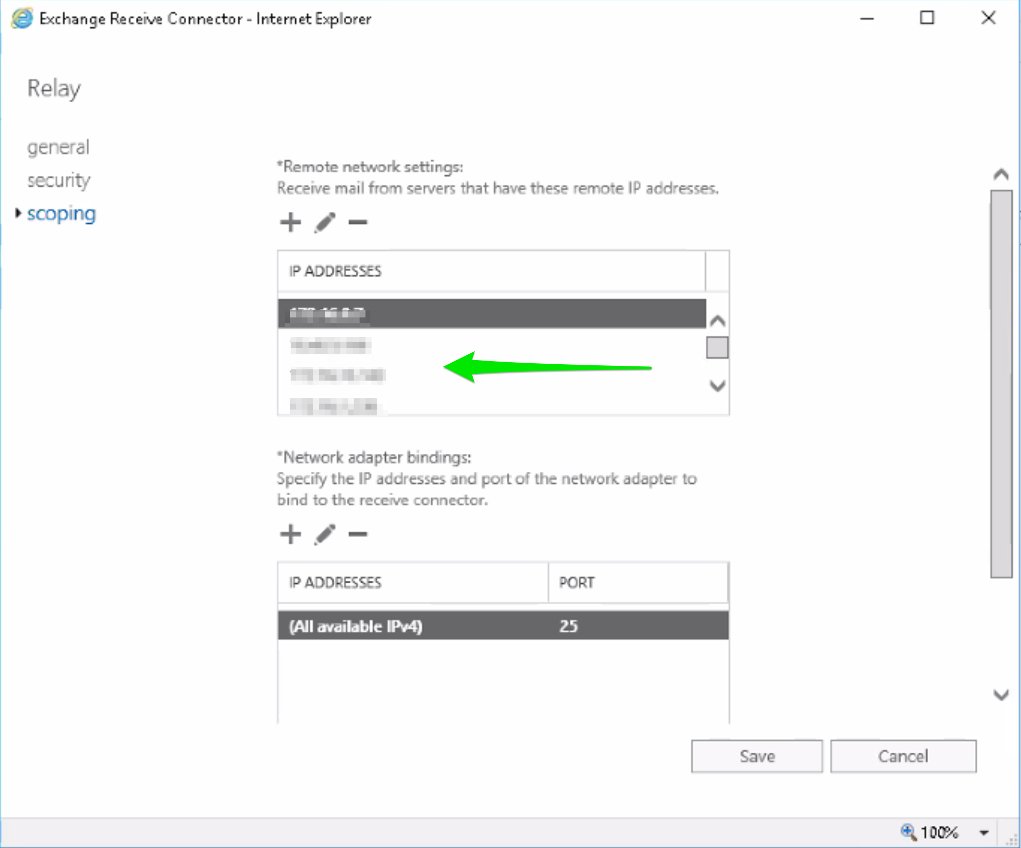

4. Maintenance & Management aspects

4.1. Customer’s monitoring and log collection
SpecterX can enable the integration of existing monitoring and log aggregation solutions to monitor the on-prem segment of its solution.
We support the following methods of monitoring:
- Agent-based log shipping
- Remote or agent-based service monitoring command execution by a non-privileged user

As monitoring and log aggregation solutions vary wildly - please contact us to discuss the configuration with your specific systems.

4.2. SpecterX remote service quality monitoring

4.2.1. Infrastructure and application monitoring
In order to ensure the stability and high performance of the SpecterX solution - we collect the following information about our system:
- Resource usage metrics
- SpecterX application and OS logs (sanitized - no sensitive information/PII will be sent)
- SpecterX application metrics and service health test results

This data will be collected using a monitoring agent and sent over a TLS encrypted connection to our monitoring system hosted in an AWS cloud VPC.

4.3. Deploying SpecterX Software Updates
For the first deployment SpecterX will provide pre-baked .OVF VM images on offline media that should require minimal configuration on-site. Subsequent deployments will normally consist of updated Docker images and configuration files.

4.3.1. Deploying VM OS updates
Any updates to OS and or SpecterX software will be provided as part of the SpecterX software updates cycle.

4.4. Testing and Maintenance Environment for SpecterX
It is highly recommended to set up a minimized testing environment for pre-rollout testing of the SpecterX Outlook Addin and Web application. This would greatly speed up delivery of new features as well as substantially decrease risks when rolling out new versions to end-users.

4.4.1. What we need to ensure the stability of SpecterX updates:
- A corporate email account (if needed, this email can blocked from sending email to all domains except specterx.com)
- A workstation (or virtual Desktop) environment with the same version of Microsoft Outlook as used by all end-users.
- Permissions to install/uninstall/upgrade the SpecterX Outlook Addin on the provided workstation.
- Permissions to run Powershell commands, edit “HOST” file, run CMD commands (preferred local Admin on the testing workstation)
- Remote access to this Virtual Desktop environment from SpecterX Intranet IPs (as allocated in section 2.1.2)

4.5. Contact sheet
Please fill below the names and the contact details of people in your organization who are responsible for the mentioned Roles. We will use these contacts to efficiently manage our on-prem system and for efficiently troubleshooting any issues we might encounter.

4.5.1. Customer Roles & Contacts
Role | Name(s) | Preferred contact method details
Project Lead/Manager
IT/ Infrastructure Provisioning
Information Security
Networking / Firewall / DNS

4.5.2. SpecterX Roles & Contacts
Role | Name(s) | Preferred contact method details
Project Lead/Manager
IT/ Infrastructure Provisioning
Information Security
Networking / Firewall / DNS

